# Project Design Phase-I Solution Architecture

|  |  |
| --- | --- |
| Date | 01 October 2022 |
| Team ID | PNT2022TMID36001 |
| Project Name | Smart Lender-Applicant Credibility Prediction  For Loan Approval |
| Maximum Marks | 4 Marks |

**Solution Architecture:**

A complicated process with several sub-processes, solution architecture connects business issues with technological solutions. Its goals are to:

* Track down the most effective technological remedy for current company issues.
* Explain to project stakeholders the structure, traits, behaviour, and other features of the software.
* Specify the features, stages of development, and requirements for the solution.
* Offer guidelines for how the solution is created, managed, and delivered.

# Example - Solution Architecture Diagram:

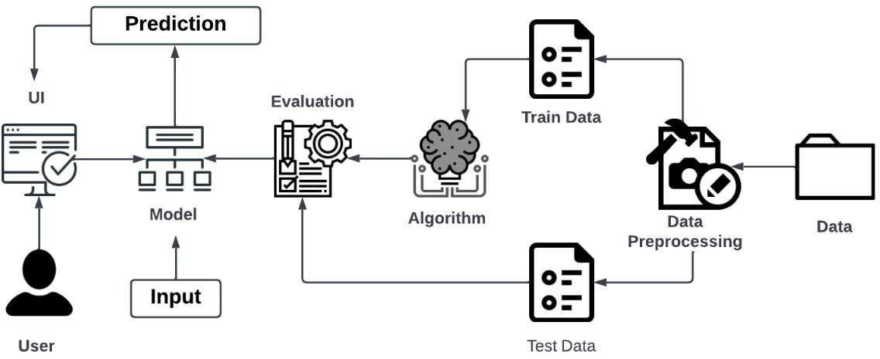

***Figure 1: Architecture and data flow of the loan approval prediction using machine learning techniques****.*